27.Write a Python programming to display a bar chart of the popularity of programming
Languages.

Aim:
To write a Python program using Matplotlib to display a bar chart showing the popularity of different programming languages.

Code:
import matplotlib.pyplot as plt
language = ["Python","Java","C","C++","JavaScript"]
popularity = [90,80,70,60,85]
plt.bar(language, popularity)
plt.xlabel("Languages")
plt.ylabel("Popularity")
plt.title("Programming Language Popularity")
plt.show()

Output:
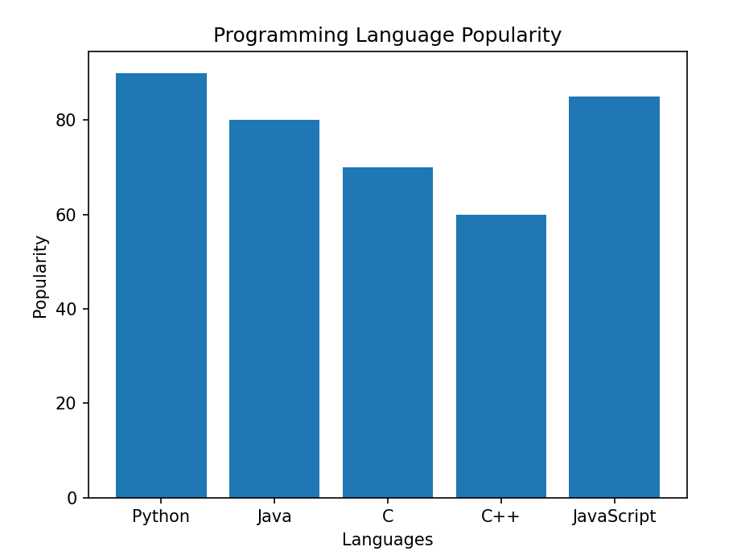

Result
The program was executed successfully, and a bar chart was displayed showing the popularity of Python, Java, C, C++, and JavaScript.

28.Write a Python programming to display a horizontal bar chart of the popularity of
programming Languages.

Aim:
To write a Python program using Matplotlib to display a horizontal bar chart showing the popularity of different programming languages.
Code:
import matplotlib.pyplot as plt
language = ["Python","Java","C","C++","JavaScript"]
popularity = [90,80,70,60,85]
plt.barh(language, popularity)
plt.xlabel("Popularity")
plt.title("Horizontal Bar Chart")
plt.show()
Output:
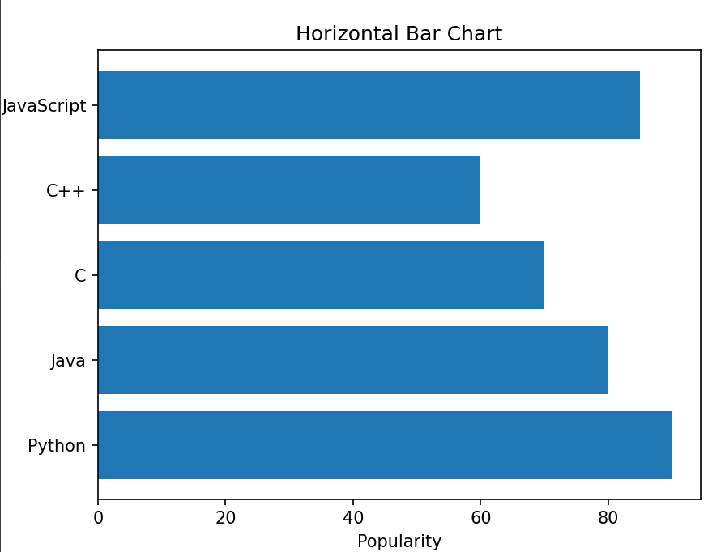

Result:
The program was executed successfully, and a horizontal bar chart was displayed showing the popularity of Python, Java, C, C++, and JavaScript

